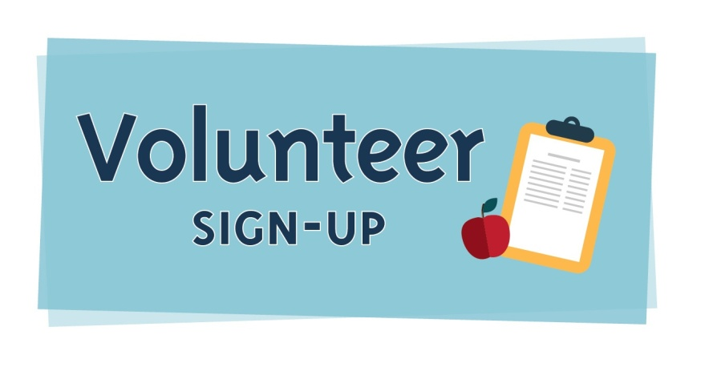
Poetic Word Ministries Inc.
PO Box 878 * Piedmont, SC 29673
Phone: 864-607-3677
www.poeticword.org

Poetic Word Ministries Inc. needs your help! We are building a community empowerment center for women and young girls. It's a one of its kind structure with an innovative and original concept that people will be talking about for years to come. Please select your area(s) of interest in volunteering below. Submit your completed registration form via email to poeticwordministries@gmail.com. Someone will be contacting you as soon as possible with times and dates for your volunteer opportunity. Thanking you in advance for your consideration in helping us to inspire others to empower their dreams!
---------------------------------------------------------------------------------------------------------------------

In which opportunity(s) below would you like to volunteer? (Check all that apply)

Poetry Sessions Fundraising Building Projects Website Development

Administrative Support Social Media Conferences & Workshops

What days are you available? (Check all that apply)

Monday Tuesday Wednesday Thursday Friday Saturday

How soon can you start?

Immediately Next Week Next Month Available only ________________

* *
___________________________ _____________________________
Name Address

* *
______________________________ ______________________________
Email Contact Number

